WR90 Waveguide parts

Version 1.0, 02/13/17

# Flange type: UG-135/U

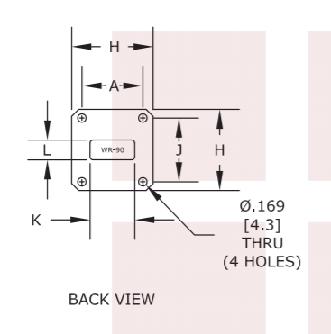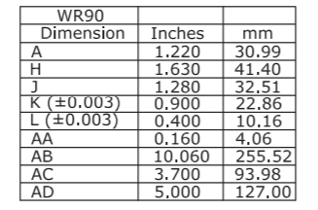

# TRL Calibration kits

1. Waveguide short plate: t = 0.125 inches

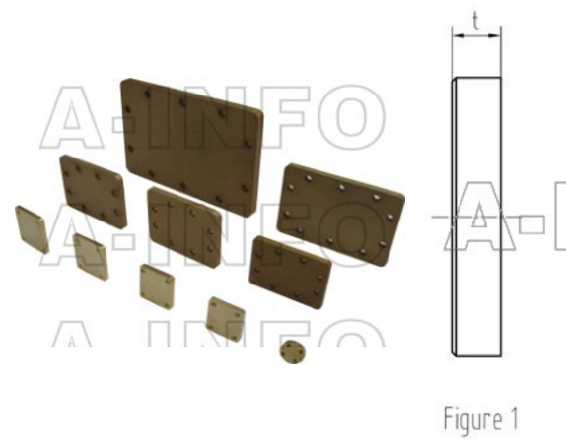

1. Quarter-wave length (shim): thickness = 9.7 mm

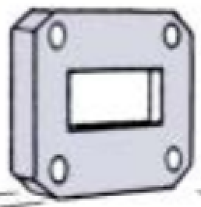

# Parts for Measurement Setup

1. Two straight sections: A = 3 inches

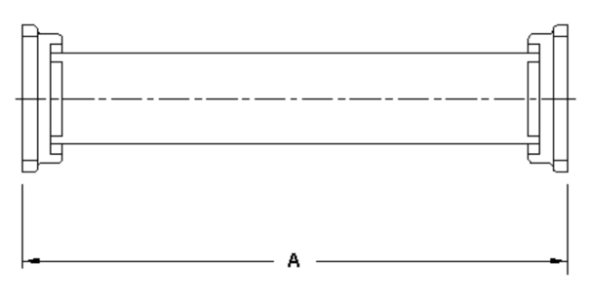

1. Sample holder (shim): the sample holder is the same as the quarter wave length line (shim), with different thickness. We can start with thickness = 5 mm



# References

* Flange picture: <https://www.fairviewmicrowave.com/images/productPDF/SH190-20.pdf>
* Short, quarter wavelength shim: <http://www.ainfoinc.com/en/p_spacer.asp>
* Straight section: http://www.waveline-inc.com/catalog/cp24.htm